March 3, 2023

Subject: Section 106 review for Trenching for Parking Lot 1 Lighting

4020 Civic Center Drive San Rafael, CA 94903-4173

Dear Consulting Parties:
You have previously expressed an interest in consulting on proposed undertakings related to Golden Gate Village (GGV). As you know, GGV is listed in the National Register of Historic Places. It is, therefore, a historic property for the purpose of Section 106 of the National Historic Preservation Act (Section 106).
For the undertaking, Marin Housing Authority (MHA) proposes to trench for electrical conduit between Building B-12 and the existing pole lights at Parking Lot 1. The proposed trenching route would cut through and cross two sections of concrete sidewalk approximately 10-feet and 6-feet and one section of parking lot 18-feet across. Sidewalks would be repaired with in-kind materials to match adjacent slabs. Junction boxes would be installed as necessary in the triangular Parking Lot 1 grassy island. MHA has concluded that the proposed undertaking would not cause an adverse effect on the historic property. Please see the attached Finding of Effect Memorandum (FOE) for a detailed analysis supporting this conclusion.
With the assistance of its Secretary of the Interior Standards (SOIS)-qualified consultant, MHA has assessed the proposed undertaking at GGV to determine its potential for adverse effect through the application of the Criteria of Adverse Effect (36 CFR 800.5(1)).
This finding is being issued for consulting party comment at this time. We request your written comment within 30 days of posting via email to the following address: ggvpubliccomment@marincounty.org.
Sincerely,
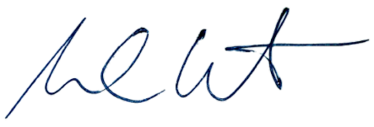
Michael Cutchin MHA

Enclosures
Finding of Effect Memorandum

Housing Authority of The County of Marin
415/491-2525
(FAX) 415/472-2186 (TDD) 1-800-735-2929
www.marinhousing.org

